REOPENING OF SCHOOLS
GMB is in communication with the Department of Education about how schools could safely reopen. Issues being raised by GMB about how all our members, within the school setting, will be kept safe include
- How will social distancing be maintained?
- What hours are being proposed for schools to be open? GMB is concerned at the possibility of rush hour travel and crowded public transport.
- Will pupil numbers be limited to ensure social distancing and to minimise the spread of infection?
- What will be the implications for site staff and cleaning staff if stricter hygiene measures are introduced?
- How will external contractors be used/managed on site?
- What PPE will be provided and what assurances can be given surrounding stock and supply?
- Will there be demarcation of work spaces in kitchens and throughout the school?
- Because of the practicalities with regular handwashing, will alcohol gels be provided?
- The need for risk assessments to be completed in advance of reopening to protect all staff
- Protocols for new safe working e.g. One to One, First Aid
This is not an exhaustive list but will hopefully give you an indication of the issues GMB is trying to address on your behalf. This said though, GMB needs to know what your concerns are and we would be most grateful if you would email schoolsteamlondon@gmb.org.uk with details of what needs to be considered for you to feel safe and happy to return to work.
Feedback from our members is key and if you have examples of good practice you would like to share with us that could benefit others, please do so on the email address above.
LOCAL GOVERNMENT & SCHOOLS PAY AWARD LATEST
The Local Government Association (LGA), has made a 2.75% pay offer for 2020/21. GMB is calling on the Government to heed the call from the local government employers to fund a top up on this, to reward council and school support staff. GMB is continuing to make representations to ensure the best settlement for our Members who have shown, throughout this crisis, how valuable and important they are to the entire Country. As a democratic Trade Union, GMB Members will be given the opportunity to have their say on pay through a consultative ballot.
TRAINING
GMB’s core purpose is that every member should have opportunity to discover and develop their talents. Please see below for details on the Aim High Project which may be of interest to you.
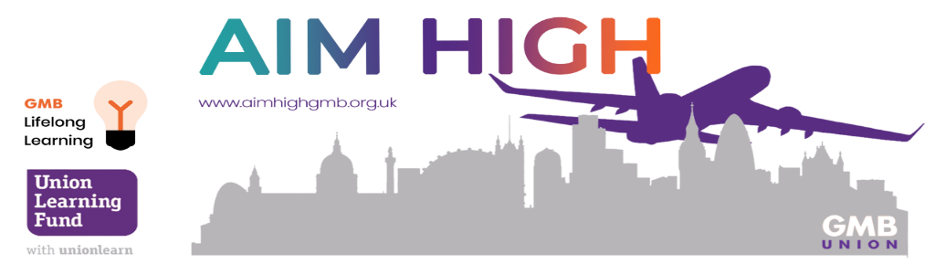
Ever wanted to expand your knowledge on a particular subject but yet just couldn’t find the time? Or perhaps put yourself forward for that promotion though fear there are colleagues more qualified in your field?
As part of your GMB membership, you have access to FREE Lifelong Learning through the Aim High Project, with over 50 Distance Learning Courses in industries such as:
· Childcare & Education
· Health & Social Care
· Business Administration
· Employability & IT
· And Retail & Hospitality
… we are bound to have something that will pique your interest!
These courses can be carried out in your own time, in your own home and at your own pace, receiving a full level 2 qualification on completion.
We also have over 25 unaccredited refresher courses in Functional Skills and GCSE Maths, English and IT.
All of our courses can be found on our website www.aimhighgmb.org.uk under the ‘Course Finder’ tab, where you can easily apply and enrol.
If you need any more information on the Aim High Project or any of our courses, please contact your Project Worker, Rachel McNamara at rachel.mcnamara@gmb.org.uk

