NEW MEMBER- NJC BALLOT

MEMBER- NJC BALLOT

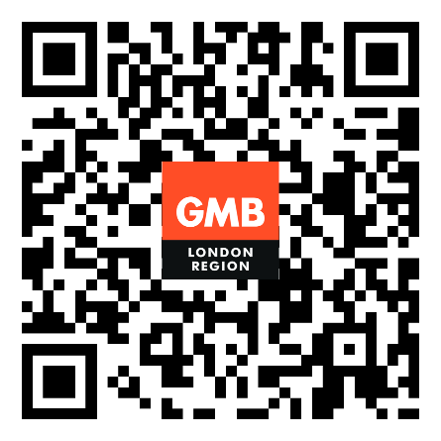

UPDATE MEMBER DETAILS

