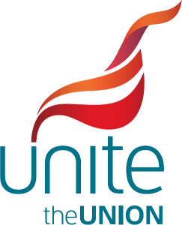

Joint GMB, UNISON and Unite statement on the outcome of their complaint against the NEU

Late last year, having failed to reach an agreement informally, the GMB, UNISON and Unite submitted a formal complaint to the TUC about the NEU’s organising activities and recruitment of school support staff.

The complaint alleged that the NEU had actively sought to recruit school support staff and had intervened in pay negotiations (known as the NJC) between the three recognised unions and the local government employers, which cover school support staff.

This undermined a previous agreement between all four unions around two fundamental TUC principles: which essentially require unions not to recruit nor organise in areas already covered by other recognised TUC unions.

Following a TUC disputes panel hearing the TUC issued its judgement the end of March 2023, which has now been presented to the TUC General Council. This upheld all the complaints against the NEU.

The judgement reaffirmed that the NJC unions (GMB, UNISON and Unite) have exclusive bargaining rights for school support staff. It also explicitly stated that in future the NEU should take no action that could be regarded as organising activity among these workers.

In recognition that the NEU’s activities had led to the recruitment of support staff, the TUC awarded financial compensation of £153,952* to be paid by the NEU in proportion to the NJC unions’ school membership. The TUC also requires the NEU to put a statement on its website acknowledging the TUC's judgement. This must say that the NEU cannot collectively bargain for support staff, will not seek recognition for them, nor undertake any campaign or organising activity that infringes on the NJC unions’ bargaining arrangements. Finally, the TUC asked the NJC joint unions to agree with the NEU a way for their members’ views to be consulted on – however the NEU remains not party to any NJC negotiations.

The three unions would have preferred not to have had to bring the formal complaint in the first place but are satisfied with the outcome. Our hope is now that all unions can return to their previous good relationships and get back to joint campaigns for better investment in education and the school workforce.

