

Trade Union Side of the National Joint Council for Local Government Services:  
England, Wales and Northern Ireland

1

NJC PAY CLAIM 2025-26

This NJC pay claim for 2025-26 is made by the Joint Trade Union Side (UNISON, GMB and UNITE) to the NJC National Employers.

Our claim is for:

* An increase of at least £3,000 across all NJC spinal column points

In addition:

* A clear plan to reach a minimum pay rate of £15 an hour
* One extra day of annual leave for all staff
* A reduction in the working week by two hours, with no loss of pay
* The ability for school staff to take [at least] one day of their annual leave during term time, with no loss of pay

31 JAN 2025

CONTENTS

2

1. KEY POINTS IN OUR CLAIM
2. CONTEXT OF OUR CLAIM
3. ECONOMIC BACKGROUND
4. COMPARING NJC PAY
5. ACHIEVING A £15 PER HOUR MINIMUM RATE
6. RECRUITMENT AND RETENTION CRISIS
7. PAY-RELATED CONDITIONS OF WORK
8. EQUALITY IMPACT
9. CONCLUSION

1. KEY POINTS IN OUR CLAIM

3

ECONOMIC BACKGROUND

* Cost of Living Crisis: Household costs, including mortgage interest, energy bills, and childcare, have significantly outpaced NJC pay increases
* Real Wage Decline: NJC staff have lost approximately 25% of their pay's value since 2010
* Debt and Financial Strain: Many NJC workers rely on credit cards and loans to make pay household bills and make ends meet
* Government Savings: Increasing local government pay would result in significant savings for central government through higher tax receipts and reduced benefit expenditure.

COMPARING NJC PAY

* Private vs. Public Sector Pay: Pay settlements in the private sector have generally outpaced those in the public sector since 2010.
* National Minimum Wage: The NJC pay spine is close to the new statutory minimum wage, highlighting the need for significant pay increases.

ACHIEVING A £15 PER HOUR MINIMUM RATE

* £15 p/h is fast becoming a necessity: Inflation and cost of living rises have made calls for a £15 per hour minimum rate stronger than ever
* In-work poverty: £15 p/h would lift the lowest paid NJC workers out of in-work poverty
* Achieving £15 p/h for the NJC: The 2025-26 NJC pay claim would lift SCP2 to £13.82. A subsequent pay award of the same value would lift SPC2 to £15 p/h by 2026
* The TU side asks national employers: to prioritise a route to achieve a £15 per hour minimum for the NJC, as quicky as possible.

RECRUITMENT AND RETENTION CRISIS

* Shrinking LG workforce is a long term trend: The County Councils Network (CCN) Survey reveals that the number of employees in England’s councils has reduced by 552,000 (31.5%) since 2012
* Unemployment: Remains low nationally at just over 4%, through to October 2024 – lower than at almost any point in the last 40 years
* Solving the Recruitment and Retention Crisis: Low pay is routinely given as the reason for leaving – a boost to NJC pay would help to prevent further loss of staff, in addition, better training and clear career pathways would help to retain younger employees

PAY-RELATED CONDITIONS OF WORK

* A clear plan to reach a minimum pay rate of £15 an hour
* One extra day of annual leave for all staff
* A reduction in the working week by two hours, with no loss of pay
* The ability for school staff to take [at least] one day of their annual leave during term time, with no loss of pay

EQUALITY IMPACT

* Gender Pay Gap: Women in English local authorities were paid 3.5 per cent less than men according to mean pay and 1.7 per cent less than men according to median pay.
* Ageing workforce: Local government has an ageing workforce and in certain key professions this is reaching a crisis point

**2. CONTEXT OF OUR CLAIM**

4

NJC staff have lost (on average) 25% from the value of their pay since 2010. This long term decline has been compounded by more recent economic events, including the latest Cost of Living Crisis.

Over the course of 2024, our members in local government have seen their household costs, including mortgage repayments, energy bills, and childcare, significantly outpace NJC pay increases.

The bottom end of the NJC pay spine is close to the new statutory minimum wage, highlighting the need for significant pay increases – to reverse this trend and to recover years of lost value in local government workers’ pay.

Employers have also felt the effects of this decline - the County Councils Network survey, published in 2024, reveals that the number of employees in England’s councils has reduced by 552,000 (31.5%) since 2012 and low pay is routinely given as a key reason for staff leaving. Meanwhile, nationally unemployment remains lower than at almost any point in the last 40 years. With a vibrant jobs market, overworked and underpaid local government staff are being lured away to better paying, less demanding jobs.

While an overall pay boost is needed for the whole pay spine, it is lower paid staff who have felt the worst impact of the cost of living crisis, with many driven into significant personal debt just to make ends meet. **This is why the TU side are renewing our calls to deliver a £15 per hour minimum rate in the NJC as soon as possible.**

It is encouraging that the new government has recognised the issue of local government funding as a key factor in restoring our broken public services and encouraging growth within local economies and communities. Proposals to move towards multi-year funding settlements for local government will bring more stability and certainty to local authorities.

The importance of the national funding settlement for local government is demonstrated clearly in our commissioned research, showing that around half the cost of this pay claim would actually be recouped by central government. With the new government’s focus on local government funding, the TU side feels that now is the right time for the employers to join us in making the case directly to government for more central funding to support better services and a fully funded pay award.

Our headline claim for an increase of at least £3,000 on all spinal column points would begin to restore over a decade of lost value in NJC pay. Our headline claim is supported by some additional conditions:

* **One extra day of annual leave for all staff**
* **Reduction in the working week by two hours**
* **The ability for school staff to take [at least] one day of their annual leave during term time**

The TU Side believes our headline claim is fair and appropriate - and we expect meaningful negotiations on our claim.

**3. ECONOMIC BACKGROUND**

5

**3.1 Cost of living crisis continues**

Over 2024, household costs continued to overtake NJC pay increases for the same period. Mortgage interest payments led the way, jumping by 18.8% over the past year1, followed by the typical household electricity and gas bill, which rose almost 10%. Water charges increased by 8.1% and the average cost of a part time (25 hours a week) childcare place for a child under two in a nursery rose by 7.4% to £7,569 per year (for a two-year-old that cost has jumped 6.2%)2. Council tax rose by 4.9%. Over the same period, NJC pay rose only 4.3% (on average, across all spinal column points), as shown in the graph below:

**Graph 1: Cost of living increases Vs NJC pay 2024**

These increases have left many NJC workers reliant on credit cards and loans to make ends meet – incurring debt that is carried forward month to month. Despite inflation rates returning to more conventional levels, this debt burden is one of the many reasons (along with historic loss in value) why NJC pay needs to rise above inflation.

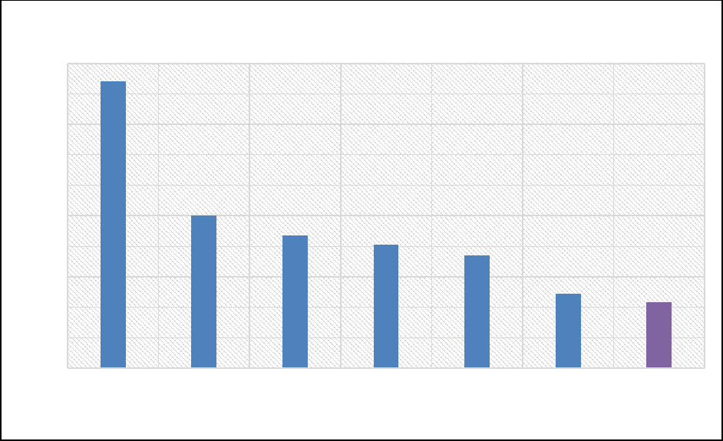

20.00%

18.00%

16.00%

14.00%

12.00%

10.00%

4.00%

8.00%

6.00%

0.00%

2.00%

Mortgage  
interest  
payments

18.80%

**2024 Household cost increases Vs NJC pay increase**

Typical  
houshold  
energy bill

10%

Monthly rent  
for new  
tenancies

8.70%

Water charges Childcare Council tax NJC Pay

Increase 2024‑

25

8.10%

7.40%

4.90%

4.30%

**3.2 Value of NJC pay**

When measured against the overall rise in inflation since 2009/10, NJC staff are losing out. On average, staff have lost approximately 25% from the value of their pay since 2010.

When analysed by job role, even those on lower incomes (who have benefited from bottom loading in some pay awards), are worse off than they were in 2009/10.

1 Office for National Statistics, Private Rent and House Prices UK, November 2024

2 Coram Family and Childcare Survey, March 2024

Table 1: Real (RPI) changes to selected spine points 2009/10 to 2023/24

6

Real (RPI) changes to selected spine points 2009/10 to 2024/25

|  |  |  |  |  |  |
| --- | --- | --- | --- | --- | --- |
| Occupation | Old Spine Point | 2009/10 | 2024/25 | New Spine Point | Real change (%) |
| Cleaner | 6 | £12,489 | £23,656 | 2 | -4.80 |
| Customer Services Officer | 11 | £14,733 | £24,027 | 3 | -13.4 |
| Refuse And Recycling Collector | 13 | £15,444 | £24,404 | 4 | -16.1 |
| Library Assistant | 16 | £16,440 | £25,183 | 6 | -18.7 |
| Teaching Assistant (Level 2) | 17 | £16,830 | £25,183 | 6 | -20.6 |
| Crematorium Officer | 18 | £17,161 | £25,584 | 7 | -20.9 |
| Qualified Residential Care Worker | 21 | £19,126 | £27,269 | 11 | -24.3 |
| HLTA | 28 | £23,708 | £32,654 | 22 | -26.9 |
| Librarian | 31 | £26,276 | £35,235 | 25 | -28.8 |
| Environmental Health Officer | 34 | £28,636 | £37,938 | 28 | -29.7 |
| Access to Housing Officer | 38 | £31,754 | £41,511 | 32 | -30.6 |
| Social Worker | 36 | £30,011 | £39,513 | 30 | -30.1 |
| Accountant | 41 | £34,549 | £44,711 | 35 | -31.3 |
| Children’s Residential Manager | 46 | £38,961 | £49,764 | 40 | -32.2 |

3.2 Falling value in NJC Pay

Inflation exploded over 2021 and into 2022, hitting the highest rates seen across the economy in four decades. Over most of 2023 and into 2024, rates were in decline and by August 2024 the RPI rate stood at 3.4% and the CPI rate at 2.3%.

Graph 2: UK Inflation Rates 1026-20243

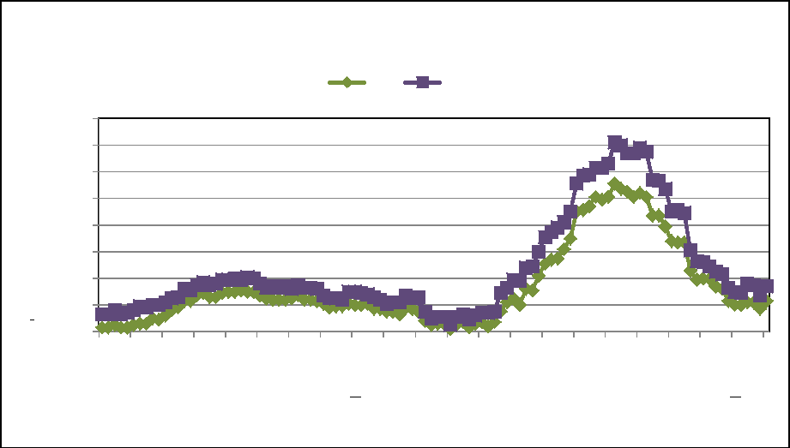

% change over 12 months

16.0

14.0

12.0

10.0

4.0

8.0

0.0

6.0

2.0

Jan-16 Jun-16 Nov-16 Apr-17 Sep-17 Feb-18 Jul-18 Dec-18 May-19 Oct-19 Mar-20 Aug-20 Jan-21 Jun-21 Nov-21 Apr-22 Sep-22 Feb-23 Jul-23 Dec-23 May-24 Oct-24

Inflation rates

CPI RPI

Year / Month

3 Office for National Statistics, UK Consumer Price Inflation: November 2024

Between the start of 2010 and the end of 2024, the cost of living, as measured by the Retail Prices Index, rose by 57.6%. Over the same period, NJC pay rose by 21.2%.

7

3.3 Impact on real wages

Recent years have seen the steepest rises in the cost of living facing workers in over 40 years - 11.6% in 2022 and 9.7% in 20234. This has accelerated the decline in the value of NJC pay.

NJC workers have seen a decline in their wages of 25% since 2010, which means that 2024 wages are worth approximately £12,000 less than in 2010.

Table 2: NJC Pay Awards Vs Rise in cost of living (RPI)5

Year Annual Growth in RPI NJC Pay Award

|  |  |  |
| --- | --- | --- |
| 2010 | 4.6% | 0.0% |
| 2011 | 5.2% | 0.0% |
| 2012 | 3.2% | 0.0% |
| 2013 | 3.0% | 1.0% |
| 2014 | 2.4% | 1.1% |
| 2015 | 1.0% | 1.1% |
| 2016 | 1.8% | 1%* |
| 2017 | 3.6% | 1%* |
| 2018 | 3.3% | 2%* |
| 2019 | 2.6% | 2%* |
| 2020 | 1.5% | 2.8% |
| 2021 | 4.1% | 1.8% |
| 2022 | 11.6% | 7.0% |
| 2023 | 9.7% | 6.4% |
| 2024 | 4.3% | 3.6% |

3.4 Main factors affecting inflation

The changes in the price of components of the Retail Prices Index over the year to October 2024 are shown in the table below.

Table 3: Price changes to RPI commodities over the year to Oct 2024

Item Average % increase to October 2024

|  |  |
| --- | --- |
| Personal expenditure | 4.9 |
| Alcohol and tobacco | 4.8 |
| Housing and household expenditure | 4.2 |
| Food and catering | 2.8 |
| Consumer durables | 2.2 |
| Travel and leisure | 1.4 |
| All goods | 1.0 |
| All services | 5.0 |
| All items | 3.4 |

4 Office for National Statistics, UK Consumer Price Inflation: December 2024

5 Incomes Data Research, 2024

3.5 Forecast inflation rates

8

The Treasury average of independent forecasts states that RPI inflation will average 3.3% over 2025 and then remain around that level over subsequent years, as per the pattern shown in the graph below. These annual rates show the rate at which pay rises would be needed for wages just to maintain their current value.

Graph 3: Forecast Annual increase in cost of living6

Forecast annual increase in cost of living

2024 2025 2026 2027 2028

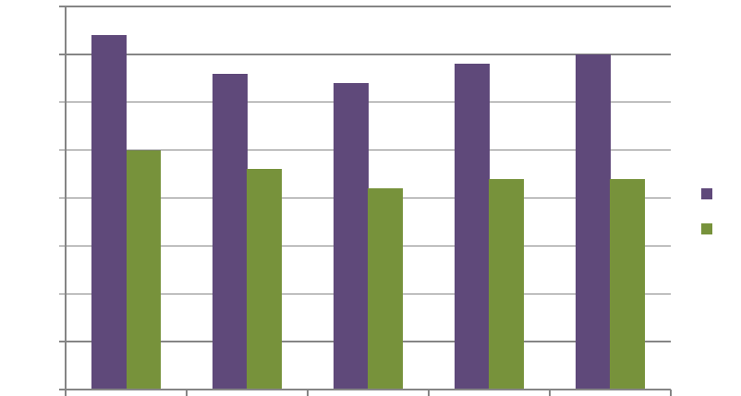

% increase

4.0

0.5

0.0

3.5

3.0

2.5

2.0

1.5

1.0

RPI CPI

2.5

3.5

3.4

3.3 3.2

2.2

2.3

2.1

2.2

3.7

3.6 Economic benefits of increasing local government pay

Research conducted by Landman Economics finds that the gross cost to local government of meeting

the 2025/26 NJC pay claim for local government workers is £1,830m in total. This includes £1,592m in salary costs, plus an additional cost of £239m in higher employer NICs.

Central government receives the £239m in higher employer NICs. Central government also benefits from additional receipts of employee NICs (£118m) and income tax (£349m) as well as reduced benefit, tax credit and Universal Credit expenditure (£62m). In total, central government saves £769m.

The net cost to the public sector as a whole (both local and central government) would be £1,062m. If indirect taxation is then factored in, central government recoups a further £170m, reducing the net cost to £892m. In total, just over half (51%) of the cost to local government of meeting the pay claim accrues to central government.

6 HM Treasury Forecasts for the UK Economy, November 2024

**Table 4: Cost of meeting the 2024/25 NJC pay Cost/Saving7**

**Cost/Saving**

|  |  |
| --- | --- |
| Gross cost to local government | £1,592m |
| + Employer’s National Insurance | £239m |
| **= Total cost to local government** | **£1,830m** |
| Employer’s National Insurance (as above) | £239m |
| + Employee’s National Insurance | £118m |
| + Income Tax | £349m |
| + Reduced benefit/tax credit/Universal Credit expenditure | £62m |
| **= Total central government savings** | **£769m** |
| **Net public sector cost:** |  |
| **= £1,830m - £769m** | **£1,062m** |
| + Indirect taxes | £170m |
| **Net public sector cost after indirect taxes:** |  |
| **= £1,062m - £141m** | **£892m** |

This research demonstrates the significant savings to government of increasing local government workers’ pay. Increased tax contributions along with reduced benefit expenditure result in central government recovering around half of the cost borne by local government.

With just over half the cost of this pay claim recouped by the government, the logic in properly funding local government pay is clear. This reinforces our calls for proper local authority funding for pay from central government. The TU side hopes that the national employers will join us in directly making the case to central government for proper local authority funding.

7 Landman Economics, 2025

9

**4. COMPARING NJC PAY**

10

**4.1 Pay settlements**

Pay settlements in the private sector have almost consistently run ahead of the public sector since 2010. While the pay freeze was in place across the public sector (2011-12), the private sector saw average rises around 2.5%, and the private sector continued to outpace the public sector by at least double the public sector rate during the ensuing period of the 1% pay cap (2013-17).

Since 2018, the gap started closing and over 2020 the public sector briefly overtook the private sector for the first time in approximately a decade.

The state’s imposition of a pay cap pushed the public rate back down to half the economy average again in 2021.

Since then, the rates have maintained approximate parity as per the graph below. However, public sector ad NJC pay are now carting a decade’s worth of lost value – which only a significant, above inflation pay award could seek to recover.

**Graph 4: Avergage Pay Settlements since 20108**

**Average pay settlements**

|  |  |  |
| --- | --- | --- |
|  | 6.0 5.0 4.0 3.0 2.0 1.0 0.0 |  |
| Percentage increase |  |
|  | 2010 2011 2012 2013 2014 2015 2016 2017 2018 2019 2020 2021 2022 2023 |

Public sector Across economy

The table below shows how average pay settlements compare with NJC pay awards. Between 2010 and 2019, NJC pay awards fell significantly behind average pay awards across the whole economy. There was some improvement after this, specifically in 2020, 2022 and 2024 - but has not been enough to recover the cumulative loss endured between 2010 and 2019 (a cumulative loss worth 18% when measured against average pay awards across the whole economy).

**Table 5: Average pay settlements VS NJC Pay Awards, 2010-2023**

**Year Average pay settlements NJC Pay Awards**

|  |  |  |
| --- | --- | --- |
| **2010** | 2.0% | 0.0% |
| **2011** | 2.5% | 0.0% |
| **2012** | 2.5% | 0.0% |

8 Incomes Data Research, 2024

11

|  |  |  |
| --- | --- | --- |
| 2013 | 2.5% | 1.0% |
| 2014 | 2.5% | 1.1% |
| 2015 | 2.2% | 1.1% |
| 2016 | 2.0% | 1%* |
| 2017 | 2.0% | 1%* |
| 2018 | 2.5% | 2%* |
| 2019 | 2.5% | 2%* |
| 2020 | 2.3% | 2.8% |
| 2021 | 2.0% | 1.8% |
| 2022 | 4.0% | 7.0% |
| 2023 | 5.6% | 6.4% |

4.2 Average earnings

Since 2021, average earnings growth has been running at relatively high rates and average earnings growth across the economy hit 4.3% in October 20249.

As in the case of pay settlements, a gap between public and private rates has been a persistent feature of the economy for more than a decade. 2020 saw the first sustained period since 2010 when the public sector has been running ahead of the private sector. But faster growth in the private sector reasserted itself strongly over 2021 and 2022, before falling back. Latest figures show the public rate at 3.5% in October 2024 against private sector earnings growth of 4.5%.

Graph 5: Average earnings growth 2016-202410

The Office for Budgetary Responsibility Economic and Fiscal Outlook published in October 2024 estimated that earnings growth will average 3.6% over 2025.

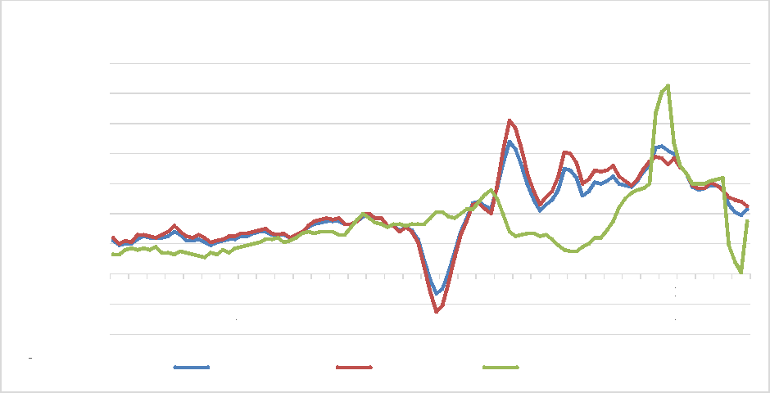

% change of 3 month yea r average on p revio u s

14.0

12.0

10.0

-2.0

-4.0

4.0

8.0

6.0

0.0

2.0

Jan 16 Apr 16

Jul 16

Oct 16

Jan 17

Apr 17

Whole Economy Private sector Public sector

Jul 17

Oct 17

Jan 18

Average earnings growth

Apr 18

Jul 18

Oct 18

Jan 19

Apr 19

Jul 19

Oct 19 Jan 20 Apr 20 Jul 20 Oct 20

Jan 21

Apr 21

Jul 21

Oct 21

Jan 22

Apr 22

Jul 22

Oct 22

Jan 23

Apr 23

Jul 23

Oct 23

Jan 24

Apr 24

Jul 24

9 ONS, Labour Market Overview, November 2024

10 Source: Office for National Statistics, Labour Market Overview UK, November 2024

4.4 NJC pay vs the wider labour market

12

The value of the UK economy (GDP) is predicted to show a small annual growth of 0.9% over 2024 and then 1.3% over 2025.11

The unemployment rate has been in decline from a peak of 8.5% in 2011 to 4.3%12 in the three months to September 2024 (rates over recent years have been at the lowest level for almost 50 years).

Forecasts now put the average unemployment rate at 4.4% in 2024 and 4.5% in 2025, though outside of recent years this level would still be a rate only last consistently experienced in the mid-1970s.

Meanwhile, the Office for National Statistics indicates that the vacancy rate across the economy was running at 2.6% in the three months to October 202413.

The number of unemployed people per vacancy was running at 1.8 by September 202414 - the trough in this rate over recent years has seen the lowest levels recorded in more than two decades and represents a dramatic decline from 5.8 in 2011.

Sector analysis shows that human health and social work retains one of the highest vacancy rates across the economy at 3.2%, while the other sectors most closely aligned with UNISON membership show rates of 2.4% for public administration, 2.2% for education, 3.8% for electricity and gas (the highest sectoral vacancy rate across the economy) and 2.6% for water supply.15

The acute issues that have been facing the health and social work category are reflected in

publications showing that the adult social care sector has a vacancy rate of 8.3% and a turnover rate of 24%.16

The impact of better wages and improved terms and conditions can be seen in the contrast between figures for local authority and outsourced social care staff. The mean hourly pay of local authority care worker staff was £12.43 in 2024, compared to £11.23 in the outsourced sector, contributing to a turnover rate of 13% among local authorities, which was half the 26% displayed among the adult social care sector’s outsourced providers17.

The proportion of employers reporting “hard to fill” vacancies is running at 36% across the economy. Sectors with particular problems include “care, social work and other healthcare activities” at 45% and compulsory education at 44%18. Turnover rates were averaging 14.4% across the economy in 202319.

11 HM Treasury, Forecasts for the UK Economy, November 2024

12 Office for National Statistics, Labour Market Overview, November 2024

13 Office for National Statistics, Labour Market Overview, November 2024

14 Office for National Statistics, Labour Market Overview, November 2024

15 Office for National Statistics, Labour Market Overview, November 2024

16 Skills for Care, The State of the Adult Social Care Workforce in England, October 2024

17 Skills for Care, The State of the Adult Social Care Workforce in England, October 2024

18 CIPD, Labour Market Outlook, Autumn 2024

19 XpertHR, Labour turnover rates 2023

4.6 National Minimum Wage

The legally enforceable National Minimum Wage (NMW) sets the floor for any pay scale. The minimum hourly rates that are due to come into force from 1 April 2025 and the change from the previous rates are set out below.

|  |  |  |  |  |  |
| --- | --- | --- | --- | --- | --- |
| and over  13 |  | 18 - 20 |  | 16 - 17 | |
| Rate from April 2025 | | | | | £12.21 | | £10.00 | £7.55 | £7.55 |
| % increase on 2024 | | | | | 6.7% | | 16.3% | 18% | 18% |
| Rate from April 2023 | | | | | £11.44 | | £8.60 | £6.40 | £6.40 |

NJC SCP 2 currently sits at £12.26 – just 5p above the new £12.21 minimum due to be introduced in April20. This is dangerously close to the new statutory rate and leaves the NJC pay spine once again playing cat and mouse with the legal minimum wage.

|  |  |  |  |  |  |  |
| --- | --- | --- | --- | --- | --- | --- |
| Category of staff Aged 21 |  | Aged |  | Aged |  | Apprentices |

4.7 The Real Living Wage

The Living Wage has become a standard benchmark for the minimum needed for low-paid staff to have a “basic but acceptable” standard of living. The rates, announced annually by the Living Wage Foundation, are currently £12.60 an hour outside London and £13.85 an hour in London21.

Studies supported by Barclays Bank have shown Living Wage employers report an increase in productivity, a reduction in staff turnover/absenteeism rates and improvements in reputation.

Consequently, there are now over 15,000 employers accredited as Living Wage employers by the Living Wage Foundation, including almost half of the largest companies listed on the UK Stock Exchange and household names such as Aviva, Barclays, HSBC, Nationwide, Google and IKEA are among them.

Within the public sector, the Living Wage has now long been set as the minimum pay rate across all Scotland’s public sector organisations and this was extended to social care workers in Scotland’s private and voluntary sector from October 2016. Similarly, the Welsh Government has committed to achieving a Living Wage minimum in social care by 2024.

These latest Foundation Living Wage rates mean that Local Government is now competing in a labour market where many comparable employers are paying more to entry level or low paid staff – with SCP 2 and 3 currently falling below the £12.60 UK Foundation Living Wage rate (SCP 1 was deleted from 1 April 2023):

Table 8: NJC SCPs Vs the Foundation Living Wage

SCP* 2024 Annual 2024 Hourly

|  |  |  |
| --- | --- | --- |
| 2 | £23,656.00 | £12.26 |
| 3 | £24,027.00 | £12.45 |
| 4 | £24,404.00 | £12.65 |

*\*SCP 1 deleted from 1 April 2023*

20 UK Government, 2025 national minimum wage rates, announced 2024

21 Living Wage Foundation, 2024

**5. ACHIEVING A £15 PER HOUR MINIMUM RATE**

Despite the legal national minimum wage increasing to £12.21 per hour in April 2025, years of

rampant inflation and cost of living rises to core household outgoings (like food, housing and energy) mean that calls for a £15 per hour minimum rate are stronger than ever22. For local government

workers, this would bring many benefits, including a significant boost to those struggling with the low pay, lifting people out of in-work poverty and providing a direct boost to the lowest paid workers. This level of increase would lead to higher job satisfaction, reducing turnover rates and the costs associated with hiring and training new employees.

If answered in full, our NJC pay claim for 2025-26 would lift the lowest pay point to £13.82. A subsequent pay award of the same value in the following year would lift SPC2 to £15 p/h/ by 2026 – a significant achievement for a pay spine that has (in recent history) skirted minimum wage rates.

**Table 12: Roadmap to achieving £15 per hour minimum rate for the NJC pay spine by 2026**



**SCP 2024-25 2025-26 2026-27**

**Annual**

**Hourly**

**Increase**

**Annual**

**Hourly**

**Increase**

**Annual**

**Hourly**

|  |  |  |  |  |  |  |  |  |
| --- | --- | --- | --- | --- | --- | --- | --- | --- |
| **2** | £23,656 | £12.26 | £3,000 | £26,656 | £13.82 | £3,000 | £29,656 | £15.37 |
| **3** | £24,027 | £12.45 | £3,000 | £27,027 | £14.01 | £3,000 | £30,027 | £15.56 |
| **4** | £24,404 | £12.65 | £3,000 | £27,404 | £14.20 | £3,000 | £30,404 | £15.76 |
| **5** | £24,790 | £12.85 | £3,000 | £27,790 | £14.40 | £3,000 | £30,790 | £15.96 |

**The TU side therefore askes the national employers to develop a clear plan to reach a minimum pay rate of £15 an hour for the NJC, as quicky as possible.**

22 TUC, 2024

14

**6. RECRUITMENT AND RETENTION CRISIS**

15

**6.1 Recruitment and retention overview**

Local authorities are experiencing significant recruitment and retention challenges, particularly in education and social services. This crisis is exacerbated by low pay, high workloads, and budget cuts.

Local Government Employment decreased by 6,000 (0.3%) from June to September 2024, and by 11,000 (0.6%) from September 202323. Nationally, unemployment remains low at just over 4%, through to October 2024 – lower than at almost any point in the last 40 years. With low unemployment and a vibrant jobs market, local government employers are struggling to compete with employers who often pay more for less demanding work (such as administrative, retail and hospitality).

Within the education sector, 1 in 5 Teaching Assistants posts routinely go unfilled, with 18% of positions vacant in local authority-maintained schools24. A majority of schools struggle to recruit support staff, with vacancies remaining unfilled for over two months, especially in special schools.

The reasons local government staff give for leaving are primarily low pay, followed by poor job satisfaction and low morale25. Many report unmanageable workloads due to unfilled posts and budget cuts.

**6.2 Workforce survey data**

The latest LGA Workforce Survey, tells us that the Total Gross Council Pay Bill for 2023/24 was £18.6bn, down 24% from 2014/15. The average FTE Salary in local government is £28,900 – well below average, annual full-time earnings for 2024 in the UK (approximately £37,430).

The survey also reports that 94% of councils have recruitment and retention difficulties. 90% report at least one capability skills gap and 83% report at least one capacity skills gap.

This shrinking workforce is sadly a long term trend. The County Councils Network (CCN) Survey reveals that the number of employees in England’s councils has reduced by 552,000 (31.5%) since 2012. 26% of local government workers plan to work there for less than four years, with only 46% expecting to stay for over 10 years. 64% believe local government is not perceived as an attractive employer, and 42% feel they will not receive enough training to future-proof their skills.

**6.3 Solving the Recruitment and Retention Crisis**

All of the above evidence shows that improving pay will go a long way towards addressing the recruitment and retention crisis in local government. However, this must be addition to other key measures including: improving working conditions and job satisfaction, providing adequate training, offering clear career pathways to retain young employees and improving the perception of local government as an employer.

23 LGA workforce survey, 2024

24 Freedom of Information requests by TU side, 2024

25 Low Pay Commission, 2023

7. PAY-RELATED CONDITIONS OF WORK

16

7.1 Workload and Stress

Over the past decade and a half, the local government workforce has decreased significantly, leading to increased workloads for remaining employees.

Public sector workers overall are performing a substantial amount of unpaid overtime, with 16.7% of them doing so in 2023, compared to 11.9% in the private sector.

Long hours and stress are contributing to serious mental and physical health issues, including stress, depression, and anxiety. In 2023/24, 1.7 million workers reported work-related ill health, with nearly half of these cases related to mental health issues. Taking holidays and reducing working hours have been shown to improve morale, health, and productivity.

The Trade Union Side is therefore calling for:

* One extra day of annual leave for all staff

7.2 Reduction in Working Time

Reducing working hours can lower unemployment, increase productivity, reduce carbon emissions, and improve overall well-being. The standard NJC working week is 37 hours (36 in London), but some local authorities have reduced this to 35 hours without negative impacts on services.

Some employers have gone further, with over 200 UK companies have committed to a permanent four-day working week without reducing employee pay26. Companies moving to this model argue that the traditional five-day workweek is outdated and that a four-day week can enhance work-life balance, increase employee satisfaction, and maintain productivity. The move is particularly popular among younger workers, with many prioritizing mental health and well-being. In January 2023, South Cambridgeshire District Council become the first local authority to trial the 4 day week (with no loss in pay). Their initial results were positive, particularly on retention and recruitment.

The TU side recognises the complexities involved in reducing working time for some groups of staff, and we look forward to discussing them with the employers as part of meaningful negotiations.

The Trade Union Side is therefore calling for:

* A reduction in the working week by two hours, with no loss of pay (and a longer-term view of supporting the 4-day working week)

7.3 Paid personal day for school support staff

Members working as school support staff are seeking at least one guaranteed paid personal day each year, to use as they want. This is not a claim for an additional annual leave day, simply the ability to take at least a day’s leave during the school term. Many schools and academies already implement this policy. If applied universally, this will help raise the job satisfaction and work-life-balance of school support staff.

The Trade Union Side is therefore calling for:

* The ability for school staff to take [at least] one day of their annual leave during term time, with no loss of pay

26 4 Day Week Foundation, 2025

8. EQUALITY IMPACT

8.1 Gender Pay Gap

Low pay in local government disproportionately affects workers with protected characteristics under the Equality Act, particularly women workers27.

On average, women in English local authorities were paid 3.5 per cent less than men according to mean pay and 1.7 per cent less than men according to median pay. This compares to 6.1 per cent and 4.0 per cent respectively in 2018/19.

Women were, on average, paid less than men in 167 authorities, in 25 the pay gap was zero, and in 101 women were paid more than men (according to median pay).

The proportion of women was highest in the second-lowest pay quartile (63.4 per cent) and lowest in the highest quartile (57.2 per cent), a similar picture to 2018/19.

8.2 Ageing workforce

An ageing workforce and job market competition across numerous sectors continues to be recognised by industry voices as one of the fundamental challenges facing local government. The Local Government Association continues to recognise that “Local government has an ageing workforce and in certain key professions this is reaching a crisis point in an increasing number of councils.”

As reported in the Association for Public Service Excellence (APSE) in 2021, “With an ageing workforce and competition from places like retail, for jobs that are paying better with less stress, it is little wonder that care worker shortages are being acutely felt in local authority care services” and in APSE’s survey of local councils for that year, 86% of councils responding believed that an ageing workforce presented a high to medium risk to recruitment and retention of the workforce28.

27 The gender pay gap in local government 2023/24, LGA, 2024

17

28 Local government: Skills shortages and workforce capacity, ASPE, 2021

**9. CONCLUSION**

18

Our 2025-26 NJC pay claim demonstrates the crisis facing both NJC workers and local authorities. Historic low pay has eroded the value of NJC pay by 25% since 2010. This has happened against a backdrop of both increased stress/workload among local government workers and rampant inflation across the economy.

Our members’ household costs have become almost unaffordable for many, especially those on the lowest pay points. These low paid members are now seeing their pay drawing worryingly close to the new legal minimum - and falling well below the foundation living wage (and even further below a £15 per hour minimum).

Local government employers clearly recognise this situation as unsustainable, as they continue to report difficulties in recruiting and retaining staff. Many workers have already left for less stressful and better paying jobs outside of local government (in many cases outside of the public sector entirely).

With a new government bringing a new outlook to public services and local government investment, the TU side believes that now is the time for the employers to join us in making the case for decent pay and funding directly to central government. Our TU side research already shows that approximately half the cost of this pay claim would be recouped by central government through increased tax revenue and reduced welfare spend. This fact could be the starting point in a joint approach to government.

The TU Side believes our headline claim increase of at least £3,000 on all spinal column points is fair and appropriate - and we expect meaningful negotiations on our claim and the included conditions.

**APPENDIX 1: NJC SPINAL COLUMN POINTS - REAL TERMS CONVERSION\***

**19**

|  |  |  |  |  |  |  |
| --- | --- | --- | --- | --- | --- | --- |
| NJC SPINAL COLUMN POINTS - REAL TERMS CONVERSION* | | | | | | |
| Old SCP | 2009/10 | 2024/25 | New SCP | Old SCP if inflated by RPI to April 2025 | Real-terms change (£) | Real-terms change (%) |
| 8 | £13,189 | £23,656 | 2 | £24,849 | -£1,193 | -4.80% |
| 9 | £13,589 | £23,656 | £25,602 | -£1,946 | -7.60% |
| 10 | £13,874 | £24,027 | 3 | £26,139 | -£2,112 | -8.10% |
| 11 | £14,733 | £24,027 | £27,758 | -£3,731 | -13.40% |
| 12 | £15,039 | £24,404 | 4 | £28,334 | -£3,930 | -13.90% |
| 13 | £15,444 | £24,404 | £29,097 | -£4,693 | -16.10% |
| 14 | £15,725 | £24,790 | 5 | £29,627 | -£4,837 | -16.30% |
| 15 | £16,054 | £24,790 | £30,246 | -£5,456 | -18.00% |
| 16 | £16,440 | £25,183 | 6 | £30,974 | -£5,791 | -18.70% |
| 17 | £16,830 | £25,183 | £31,708 | -£6,525 | -20.60% |
| 18 | £17,161 | £25,584 | 7 | £32,332 | -£6,748 | -20.90% |
| 19 | £17,802 | £25,992 | 8 | £33,540 | -£7,548 | -22.50% |
| 20 | £18,453 | £26,409 | 9 | £34,766 | -£8,357 | -24.00% |
|  |  | £26,835 | 10 |  |  |  |
| 21 | £19,126 | £27,269 | 11 | £36,034 | -£8,765 | -24.30% |
| 22 | £19,621 | £27,711 | 12 | £36,967 | -£9,256 | -25.00% |
|  |  | £28,163 | 13 |  |  |  |
| 23 | £20,198 | £28,624 | 14 | £38,054 | -£9,430 | -24.80% |
| 24 | £20,858 | £29,093 | 15 | £39,297 | -£10,204 | -26.00% |
|  |  | £29,572 | 16 |  |  |  |
| 25 | £21,519 | £30,060 | 17 | £40,543 | -£10,483 | -25.90% |
|  |  | £30,559 | 18 |  |  |  |
| 26 | £22,221 | £31,067 | 19 | £41,865 | -£10,798 | -25.80% |
| 27 | £22,958 | £31,586 | 20 | £43,254 | -£11,668 | -27.00% |
|  |  | £32,115 | 21 |  |  |  |
| 28 | £23,708 | £32,654 | 22 | £44,667 | -£12,013 | -26.90% |
| 29 | £24,646 | £33,366 | 23 | £46,434 | -£13,068 | -28.10% |
| 30 | £25,472 | £34,314 | 24 | £47,990 | -£13,676 | -28.50% |
| 31 | £26,276 | £35,235 | 25 | £49,505 | -£14,270 | -28.80% |
| 32 | £27,052 | £36,124 | 26 | £50,967 | -£14,843 | -29.10% |
| 33 | £27,849 | £37,035 | 27 | £52,469 | -£15,434 | -29.40% |
| 34 | £28,636 | £37,938 | 28 | £53,951 | -£16,013 | -29.70% |
| 35 | £29,236 | £38,626 | 29 | £55,082 | -£16,456 | -29.90% |
| 36 | £30,011 | £39,513 | 30 | £56,542 | -£17,029 | -30.10% |
| 37 | £30,851 | £40,476 | 31 | £58,125 | -£17,649 | -30.40% |
| 38 | £31,754 | £41,511 | 32 | £59,826 | -£18,315 | -30.60% |
| 39 | £32,800 | £42,708 | 33 | £61,797 | -£19,089 | -30.90% |
| 40 | £33,661 | £43,693 | 34 | £63,419 | -£19,726 | -31.10% |
| 41 | £34,549 | £44,711 | 35 | £65,092 | -£20,381 | -31.30% |

|  |  |  |  |  |  |  |
| --- | --- | --- | --- | --- | --- | --- |
| 42  20 | £35,430 | £45,718 | 36 | £66,752 | -£21,034 | -31.50% |
| 43 | £36,313 | £46,731 | 37 | £68,415 | -£21,684 | -31.70% |
| 44 | £37,206 | £47,754 | 38 | £70,098 | -£22,344 | -31.90% |
| 45 | £38,042 | £48,710 | 39 | £71,673 | -£22,963 | -32.00% |
| 46 | £38,961 | £49,764 | 40 | £73,404 | -£23,640 | -32.20% |
| 47 | £39,855 | £50,788 | 41 | £75,089 | -£24,301 | -32.40% |
| 48 | £40,741 | £51,802 | 42 | £76,758 | -£24,956 | -32.50% |
| 49 | £41,616 | £52,805 | 43 | £78,406 | -£25,601 | -32.70% |

*Calculations are based on the change in the RPI rate between April 2009 and April 2024, which was then inflated by 3.5 per cent (the OBR October 2024 forecast for RPI growth in 2025). Inflation values are taken from ONS Consumer Price Inflation timeseries data publication (03 January 2023). Figures are rounded.

APPENDIX 2: £3,000 increases applied to NJC Pay Spine

|  |  |  |  |  |  |
| --- | --- | --- | --- | --- | --- |
| SCP | 2024-25 | |  | 2025-26 | |
| Annual | Hourly | Increase | Annual | Hourly |
| 2 | £23,656.00 | £12.26 | £3,000.00 | £26,656.00 | £13.82 |
| 3 | £24,027.00 | £12.45 | £3,000.00 | £27,027.00 | £14.01 |
| 4 | £24,404.00 | £12.65 | £3,000.00 | £27,404.00 | £14.20 |
| 5 | £24,790.00 | £12.85 | £3,000.00 | £27,790.00 | £14.40 |
| 6 | £25,183.00 | £13.05 | £3,000.00 | £28,183.00 | £14.61 |
| 7 | £25,584.00 | £13.26 | £3,000.00 | £28,584.00 | £14.82 |
| 8 | £25,992.00 | £13.47 | £3,000.00 | £28,992.00 | £15.03 |
| 9 | £26,409.00 | £13.69 | £3,000.00 | £29,409.00 | £15.24 |
| 10 | £26,835.00 | £13.91 | £3,000.00 | £29,835.00 | £15.46 |
| 11 | £27,269.00 | £14.13 | £3,000.00 | £30,269.00 | £15.69 |
| 12 | £27,711.00 | £14.36 | £3,000.00 | £30,711.00 | £15.92 |
| 13 | £28,163.00 | £14.60 | £3,000.00 | £31,163.00 | £16.15 |
| 14 | £28,624.00 | £14.84 | £3,000.00 | £31,624.00 | £16.39 |
| 15 | £29,093.00 | £15.08 | £3,000.00 | £32,093.00 | £16.63 |
| 16 | £29,572.00 | £15.33 | £3,000.00 | £32,572.00 | £16.88 |
| 17 | £30,060.00 | £15.58 | £3,000.00 | £33,060.00 | £17.14 |
| 18 | £30,559.00 | £15.84 | £3,000.00 | £33,559.00 | £17.39 |
| 19 | £31,067.00 | £16.10 | £3,000.00 | £34,067.00 | £17.66 |
| 20 | £31,586.00 | £16.37 | £3,000.00 | £34,586.00 | £17.93 |
| 21 | £32,115.00 | £16.65 | £3,000.00 | £35,115.00 | £18.20 |
| 22 | £32,654.00 | £16.93 | £3,000.00 | £35,654.00 | £18.48 |
| 23 | £33,366.00 | £17.29 | £3,000.00 | £36,366.00 | £18.85 |
| 24 | £34,314.00 | £17.79 | £3,000.00 | £37,314.00 | £19.34 |
| 25 | £35,235.00 | £18.26 | £3,000.00 | £38,235.00 | £19.82 |
| 26 | £36,124.00 | £18.72 | £3,000.00 | £39,124.00 | £20.28 |
| 27 | £37,035.00 | £19.20 | £3,000.00 | £40,035.00 | £20.75 |
| 28 | £37,938.00 | £19.66 | £3,000.00 | £40,938.00 | £21.22 |
| 29 | £38,626.00 | £20.02 | £3,000.00 | £41,626.00 | £21.58 |
| 30 | £39,513.00 | £20.48 | £3,000.00 | £42,513.00 | £22.04 |

21

|  |  |  |  |  |  |
| --- | --- | --- | --- | --- | --- |
| 31 | £40,476.00 | £20.98 | £3,000.00 | £43,476.00 | £22.53 |
| 32 | £41,511.00 | £21.52 | £3,000.00 | £44,511.00 | £23.07 |
| 33 | £42,708.00 | £22.14 | £3,000.00 | £45,708.00 | £23.69 |
| 34 | £43,693.00 | £22.65 | £3,000.00 | £46,693.00 | £24.20 |
| 35 | £44,711.00 | £23.17 | £3,000.00 | £47,711.00 | £24.73 |
| 36 | £45,718.00 | £23.70 | £3,000.00 | £48,718.00 | £25.25 |
| 37 | £46,731.00 | £24.22 | £3,000.00 | £49,731.00 | £25.78 |
| 38 | £47,754.00 | £24.75 | £3,000.00 | £50,754.00 | £26.31 |
| 39 | £48,710.00 | £25.25 | £3,000.00 | £51,710.00 | £26.80 |
| 40 | £49,764.00 | £25.79 | £3,000.00 | £52,764.00 | £27.35 |
| 41 | £50,788.00 | £26.32 | £3,000.00 | £53,788.00 | £27.88 |
| 42 | £51,802.00 | £26.85 | £3,000.00 | £54,802.00 | £28.41 |
| 43 | £52,805.00 | £27.37 | £3,000.00 | £55,805.00 | £28.93 |